Conditional Probability - Answers
June 2016 Mathematics Advanced Paper 1: Statistics 1

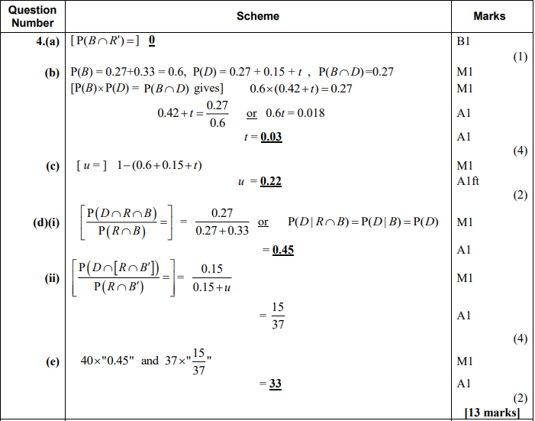
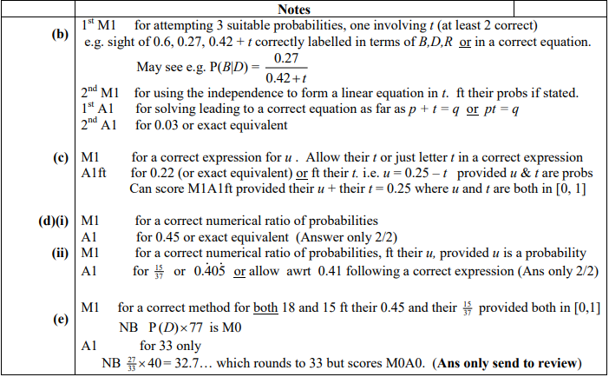

June 2015 Mathematics Advanced Paper 1: Statistics 1

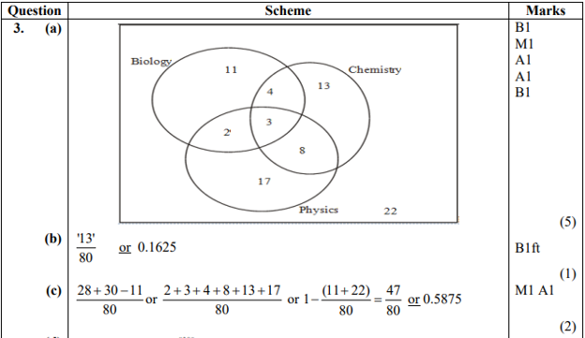
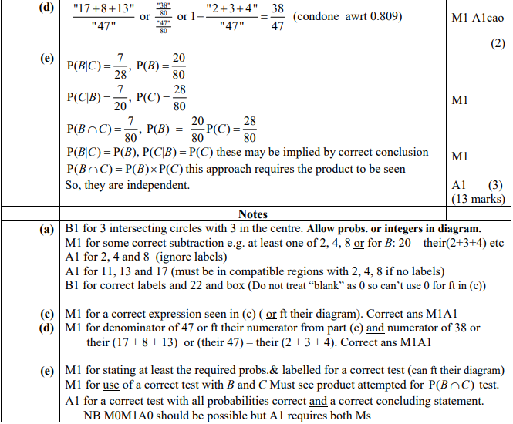

May 2014 Mathematics Advanced Paper 1: Statistics 1

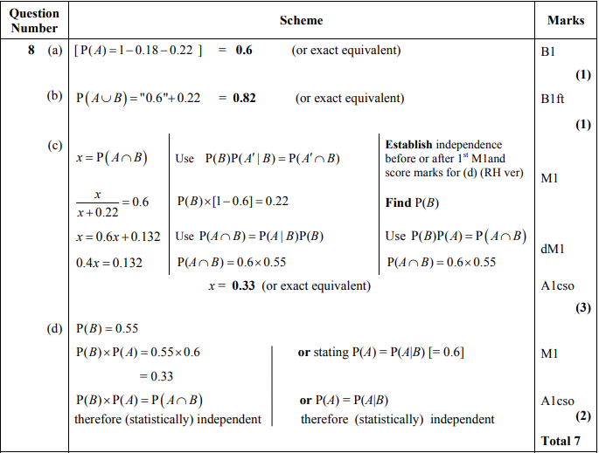
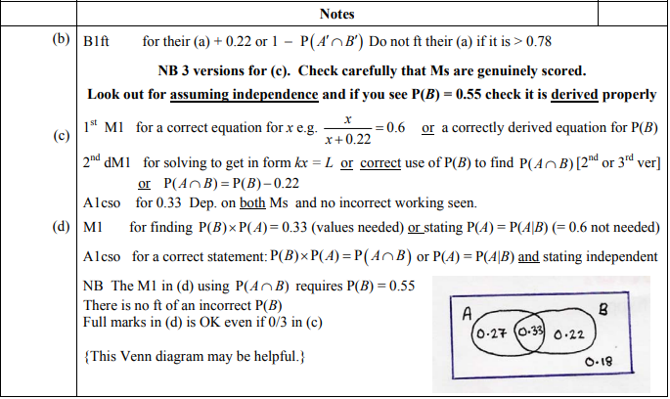
Jan 2013 Mathematics Advanced Paper 1: Statistics 1

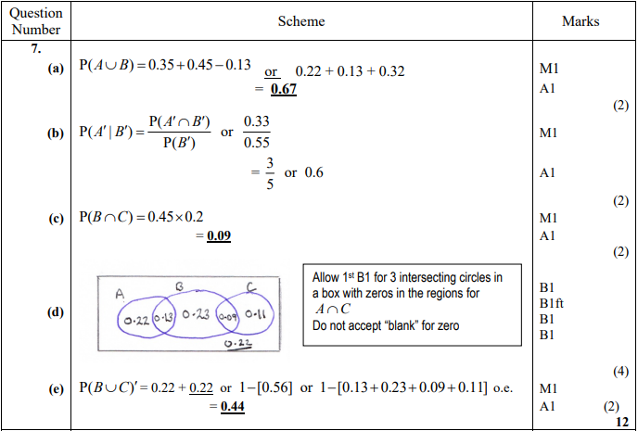
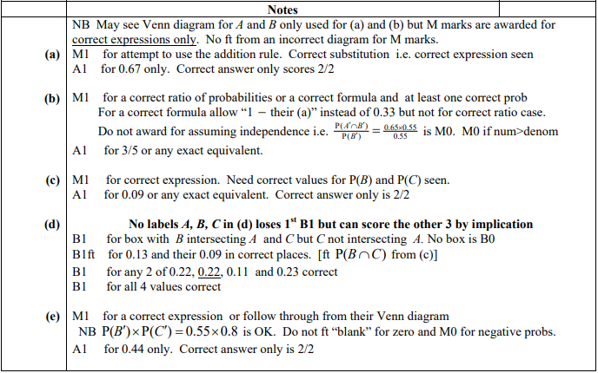
May 2010 Mathematics Advanced Paper 1: Statistics 1

